Nano-stimulator is a device that is capable of generating spike trains across multiple channels that are triggered independently. Train parameters can be controlled via LCD menu or by Ethernet communication.

**Nano-stimulator building instructions**

Components needed

1. Arduino MEGA R3 board

<http://www.amazon.com/Arduino-MEGA-2560-R3/dp/B006H0DWZW/ref=sr_1_1?ie=UTF8&qid=1348186770&sr=8-1&keywords=mega+R3>

1. Ethernet shield R3

<http://www.amazon.com/Arduino-Ethernet-Shield-R3/dp/B006UT97FE/ref=sr_1_1?s=electronics&ie=UTF8&qid=1348186793&sr=1-1&keywords=ethernet+shield+R3>

1. SainSmart LCD Keypad Shield

<http://www.amazon.com/SainSmart-Keypad-Shield-Arduino-Duemilanove/dp/B006OVYI1G/ref=sr_1_1?s=electronics&ie=UTF8&qid=1348186814&sr=1-1&keywords=LCD+shield>

1. Black box, BNC connectors, wires, LEDs, single row header, single row pins, glue gun, soldering iron and solder material, wire cutter, screws for the black box and to hold the screen (M2).
2. Take the Mega board and the Ethernet shield and connect them:

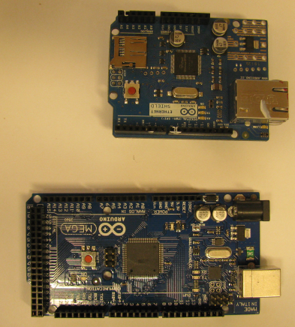 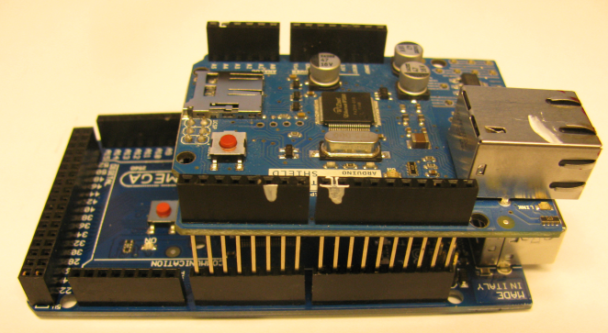

1. Connect wires to the SainSmart LCD shield

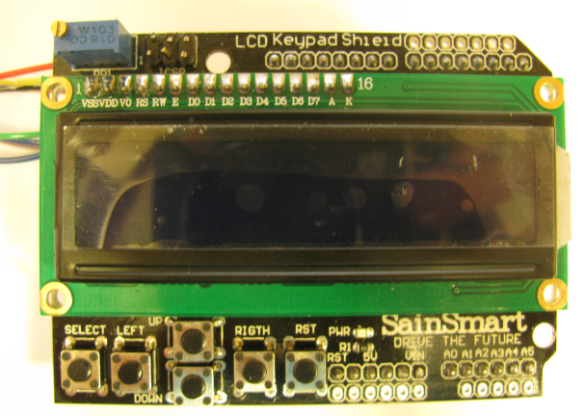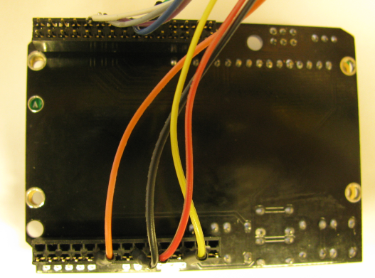

You’ll need to hookup RS,E,D4,D5,D6,D7,V5,GND,RST to wires.

1. Connect the wires to the corresponding pins in the Ethernet shield:

(RS->Pin8, E->Pin9, D4-D7->Pin4->Pin7, GND->GND, V5->V5, RST->RST)

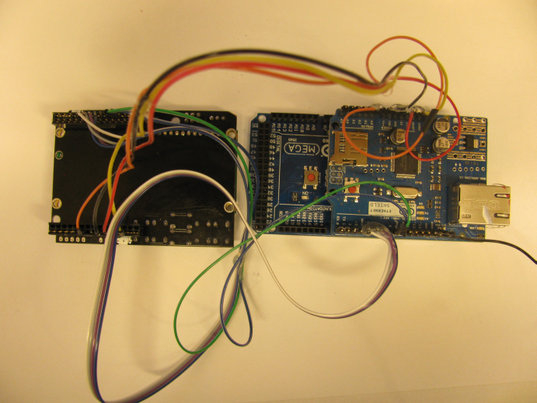

1. Prepare an enclosure with proper holes:

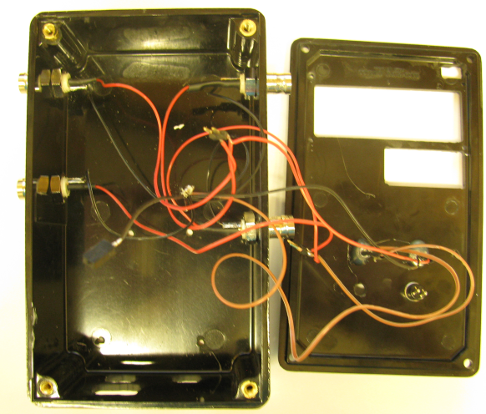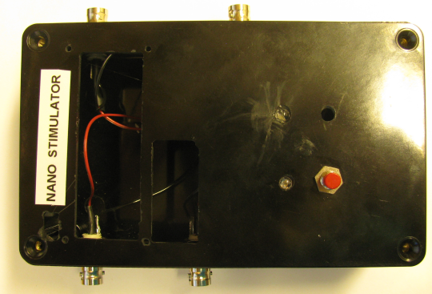

1. Place the MEGA and Ethernet shield board inside the box:

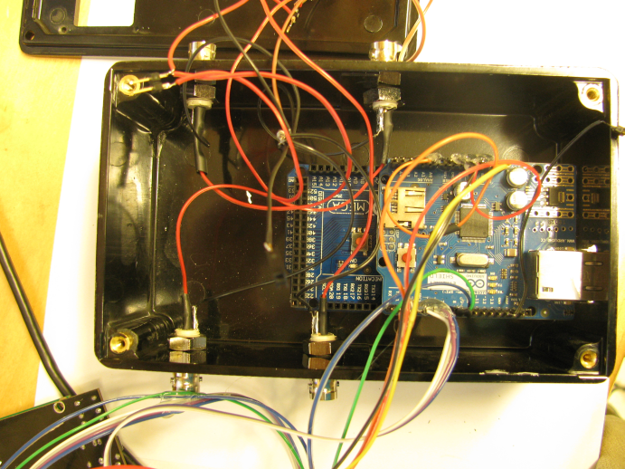

1. Hookup trigger A BNC to to pin 22 and trigger B BNC to pin 24.
2. Hookup output A BNC to pin 23 and output B BNC to pin 25
3. Connect the unit via USB
4. Install the arduino mega driver (device manager->COM ports->manual driver update
5. Open arduino IDE, load the sketch, upload to device
6. You’re ready to run!

